**Queries**

**1) Display names of representatives, details of the properties they represent, and names of their supervisors.   
Syntax:   
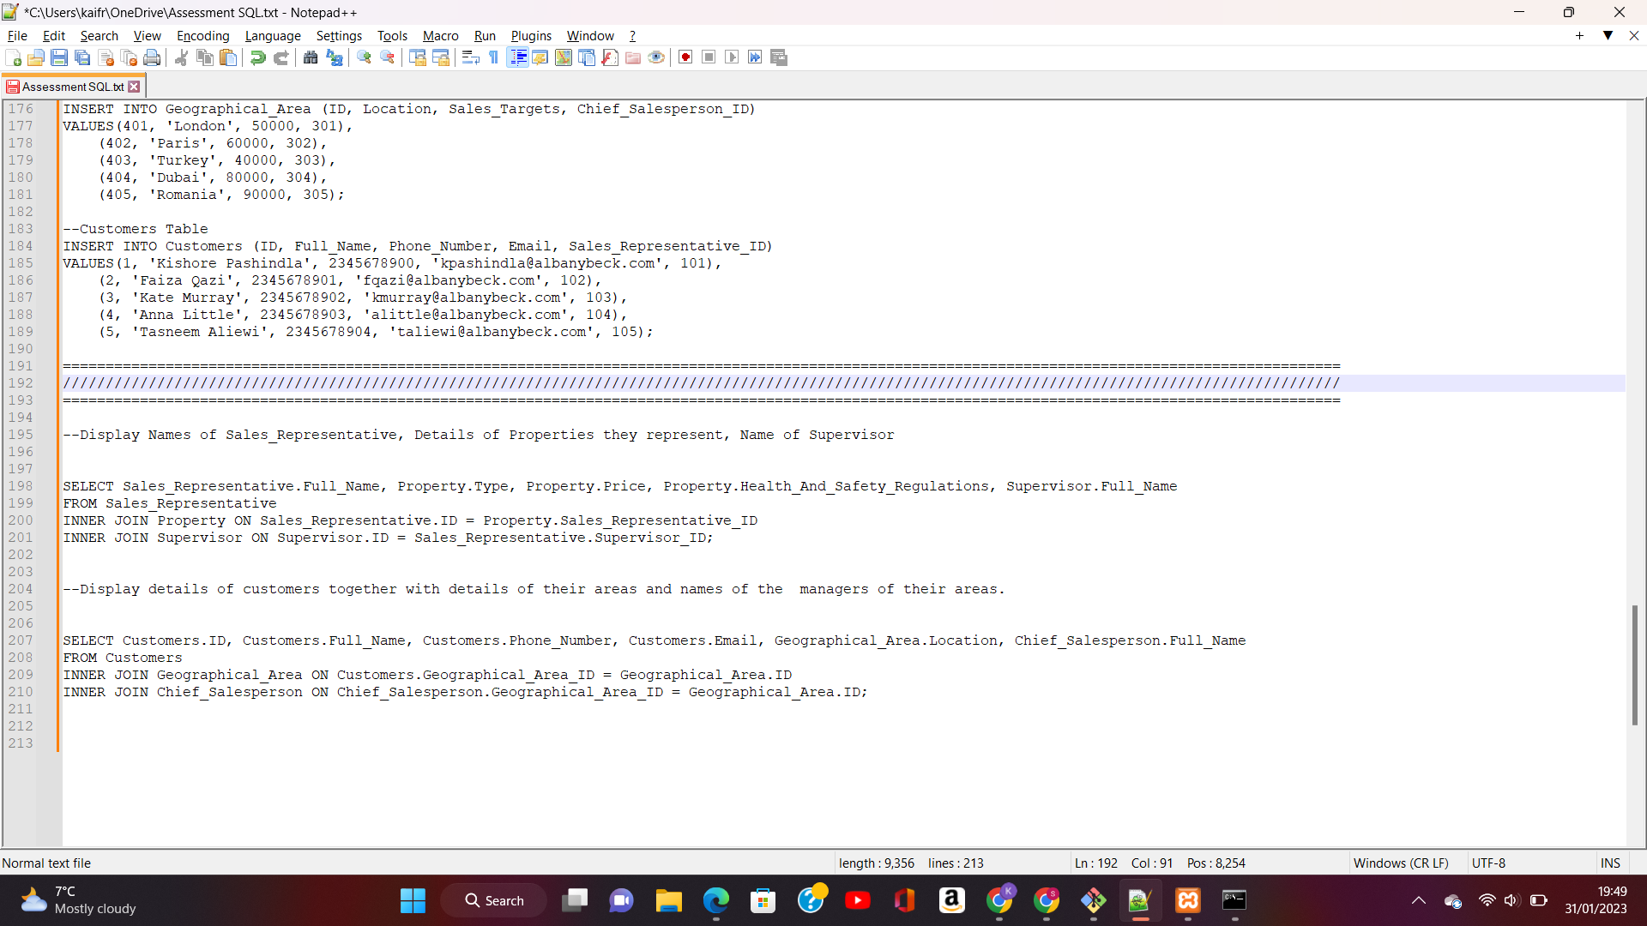  
Table:  
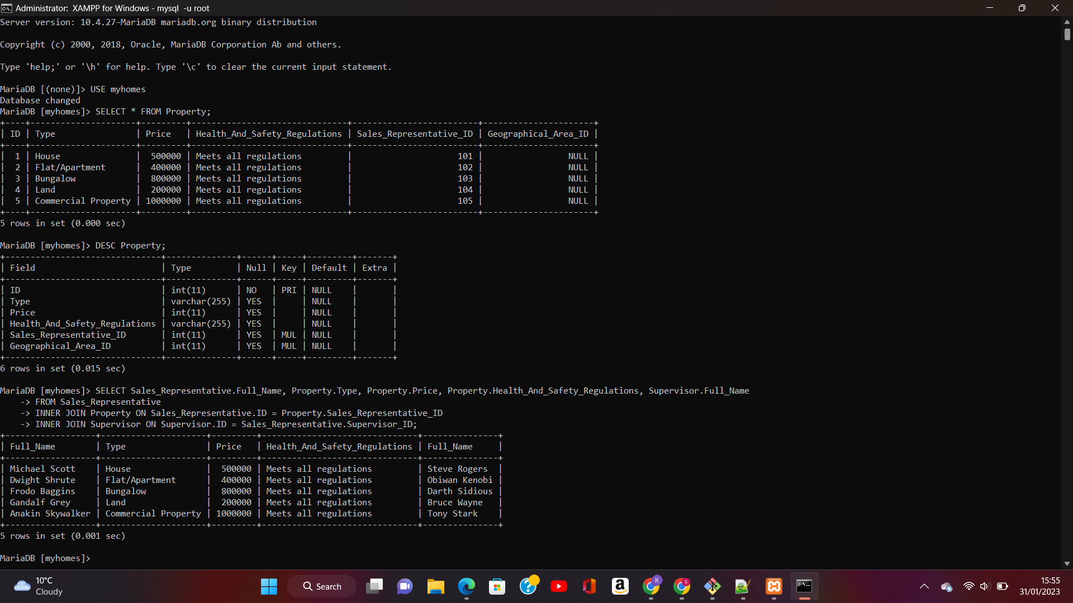**

**2) Display details of customers together with details of their areas and names of the managers of their areas.   
Syntax:**

**  
Table  
